Q1
Just before entering dry-dock a ship 5000 tonne displacement floats at draughts of 2.7 m forward and 4.2 m aft. The length between perpendiculars is 150 m and the water have a density of 1025 kg/m³. Using the given hydrostatic data, find:
- The thrust on the heel of the stern frame, which is at the aft perpendicular, when the ship just hits the docking blocks, and
- The metacentric height at the instant of setting on the blocks.

Hydrostatic Data:
KG = 8.5 m
KM_{T} = 9.3 m
MCT1cm = 105 MN
LCF = 2.7 m aft of midship
[2.18 MN; 0.39 m]

SOLUTION

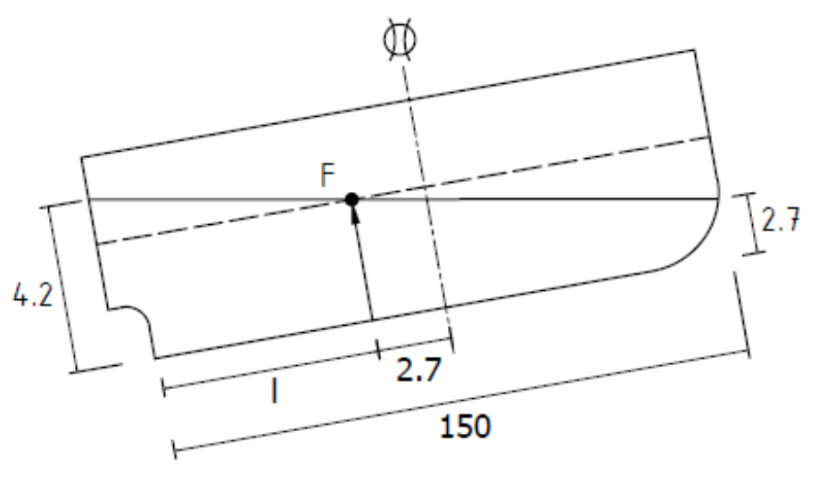

$$l=\frac{L}{2}-λ=7.5-2.7=72.3 m$$

$$P=\frac{t×MCT}{l}=\frac{\left(4.2-2.7\right)×105}{72.3}=2.718 MN$$

$$Metacentric Height=\left({GM}_{T}-\frac{P}{∆}{KM}_{T}\right)=\left(9.3-8.5\right)-\left(\frac{2.718×{10}^{3}}{5000×9.81}×9.3\right)=0.39m$$

Q2
A ship 6000 tonne displacement enters dry-dock with a draught of 4.5 m aft. If the maximum allowable thrust on the stern frame is set at 3.0 MN, determine:
- the draught forward at docking
- the virtual metacentric height
at the time of docking, given the following hydrostatic data:

- LBP = 100 m
- LCF = 2.5 m aft
- KM_{T} = 9.0 m
- KM_{L} = 105 m
- KG = 5.5 m
[a) 2.067 m; b) 3.041 m]

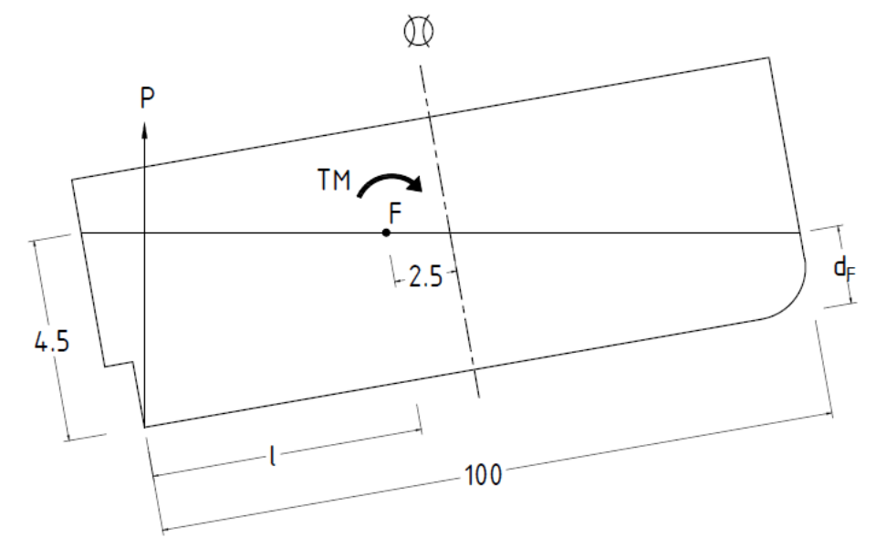

SOLUTION

$$P=\frac{t×MCT}{l}=\frac{t×\frac{∆.{GM}_{L}}{L}}{l}$$

$$MCT=\frac{∆\left({KM}_{L}-KG\right)}{L}=\frac{6000×\left(105-5.5\right)}{100}=5970 {T.m}/m=\frac{5970×g}{{10}^{3}}=58.5657 MN$$

$$l=\frac{L}{2}-λ=\frac{100}{2}-2.5=47.5 m$$

$$t=\frac{Pl}{MCT}=\frac{3.0×47.5}{58.5657}=2.433 m$$

$$d_{F}=4.5-2.433=2.067 m$$

$$Virtual {GM}_{T}={GM}_{T}-\frac{P}{∆}×{KM}_{T}=\left(9-5.5\right)-\frac{3.0}{6000×{10}^{3}×{9.81}/{{10}^{6}}}×9.0=3.041 m$$

Q3
Describe the process of docking a ship giving reasons for the actions taken.

SOLUTION

Docking Process
- On entering dock, a vessel is first aligned accurately over the blocks which have been pre-arranged to suit the ship’s bottom plan
- The dock gates are then closed and de-watering takes place. This causes the vessel to follow downwards until at the instant the stern frame hits the blocks a reaction comes into action at the stern frame
- As the water level falls and buoyancy is lost, the reaction continues to hold the weight of the ship until when finally, the whole bottom lands, the load is evenly distributed over the total number of blocks

To avoid the imposition of undue stresses on the hull, dry-docking must be carried out, in as far as possible, the same condition as she was launched when built. To achieve this, she must:
- Be in ballast condition at docking
- Enter docks with the designed stern trim
- Be upright, and
- Be in stable equilibrium (Metacentric height must be positive)

